Assignment 6

Javascript

Question 1 :

Write a JavaScript program to display the current day and time in the

following format.

Sample Output :

Today is : Friday.

Current time is : 4 PM : 50 : 22

**Output**

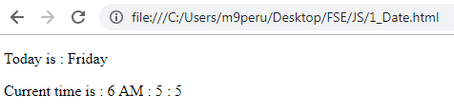

Code Snippet

<!DOCTYPE html>

<html>

<head>

<title>JavaScript Day and Hour</title>

</head>

<body>

<p id="demo"></p>

<p id="demo2"></p>

<script>

var d = new Date();

var getHour = d.getHours();

var getMin = d.getMinutes();

var getSec = d.getSeconds();

if (getHour > 12) {

var bikal = " PM";

var finalHour = getHour - 12 + bikal + " : " + getMin + " : " + getSec;

}

if (getHour < 12) {

var shokal = " AM";

var finalHour = getHour + shokal + " : " + getMin + " : " + getSec;

}

var days = ["Sunday", "Monday", "Tuesday", "Wednesday", "Thursday", "Friday", "Saturday"];

document.getElementById("demo").innerHTML = 'Today is : ' + days[d.getDay()];

document.getElementById("demo2").innerHTML = 'Current time is : ' + finalHour;

</script>

</body>

</html>

Question 2:

Write a JavaScript program to print the contents of the current window.

Output:

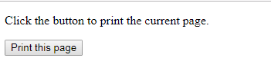

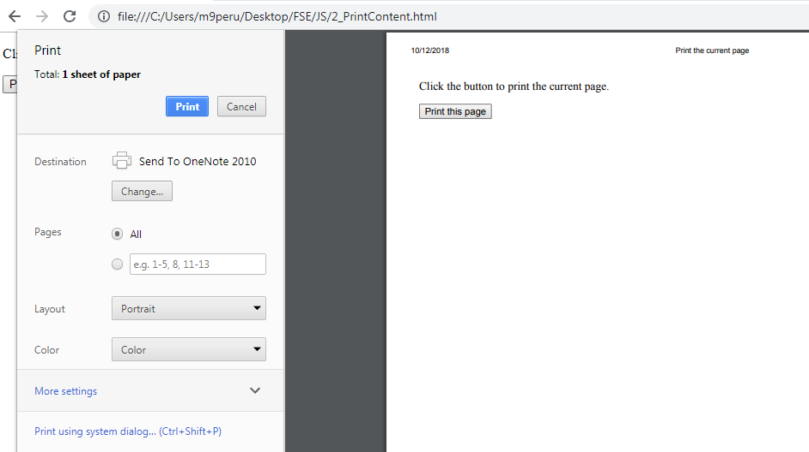

Code Snippet

<!DOCTYPE html>

<html>

<head>

<title> Print the current page</title>

</head>

<body>

<p></p>

<p>Click the button to print the current page.</p>

<button onclick="print_current_page()">Print this page</button>

<script>

function print_current_page()

{

window.print();

}

</script>

</body>

</html>

Question 3

Write a JavaScript program to get the current date.

Expected Output

: mm-dd-yyyy, mm/dd/yyyy or dd-mm-yyyy, dd/mm/yyyy

Output:



Code Snippet

<!DOCTYPE html>

<html>

<head>

<meta charset="utf-8">

<title>Write a JavaScript program to get the current date.</title>

</head>

<body>

<p id="demo"></p>

<script>

var today = new Date();

var dd = today.getDate();

var mm = today.getMonth() + 1;

var yyyy = today.getFullYear();

if (dd < 10) {

dd = '0' + dd;

}

if (mm < 10) {

mm = '0' + mm;

}

today = mm + '-' + dd + '-' + yyyy;

console.log(today);

today1 = mm + '/' + dd + '/' + yyyy;

console.log(today);

today2 = dd + '-' + mm + '-' + yyyy;

console.log(today);

today3 = dd + '/' + mm + '/' + yyyy;

console.log(today);

document.getElementById("demo").innerHTML = today + ", " + today1 + " or " + today2 + ", " + today3;

</script>

</body>

</html>

Question 4 :

Write a JavaScript program where the program takes a random integer

between 1 to 10, the user is then prompted to i

nput a guess number. If

the user input matches with guess number, the program will display a

message "Good Work" otherwise display a message "Not matched".

Output

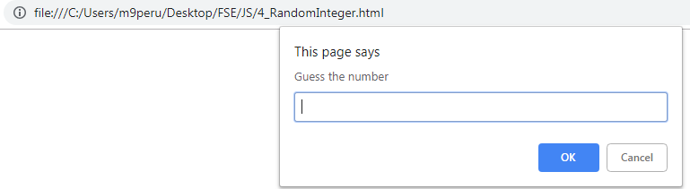

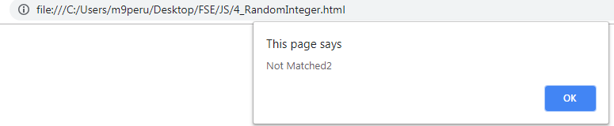

Code Snippet

<!DOCTYPE html>

<html>

<head>

<meta charset="utf-8">

<title>Guess a number</title>

</head>

<body>

<script>

var num = prompt('Guess the number');

var gnum = Math.ceil(Math.random(num) * 10);

alert('Test====' + num);

alert('Test****' + gnum);

if (gnum == num)

alert('Good Work');

else

alert('Not Matched' + num);

</script>

</body>

</html>

5.

Write a JavaScript program to calculate multiplication and division of

two numbers (input from user)

.

Sample form

Output:

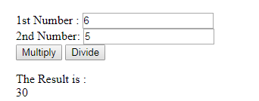

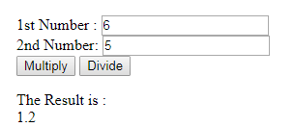

Code Snippet

<!DOCTYPE html>

<html>

<head>

<meta charset=utf-8 />

<title>JavaScript program to calculate multiplication and division of two numbers </title>

<style type="text/css">

body {

margin: 30px;

}

</style>

</head>

<body>

<form>

1st Number : <input type="text" id="firstNumber" /><br>

2nd Number: <input type="text" id="secondNumber" /><br>

<input type="button" onclick="multiplyBy()" value="Multiply" />

<input type="button" onclick="divideBy()" value="Divide" />

</form>

<p>

The Result is : <br>

<span id="result"></span>

</p>

<script>

function multiplyBy() {

num1 = document.getElementById("firstNumber").value;

num2 = document.getElementById("secondNumber").value;

document.getElementById("result").innerHTML = num1 * num2;

}

function divideBy() {

num1 = document.getElementById("firstNumber").value;

num2 = document.getElementById("secondNumber").value;

document.getElementById("result").innerHTML = num1 / num2;

}

</script>

</body>

</html>

Question 6

Write a JavaScript program to get the website URL (loading page) &

print on console

Output:

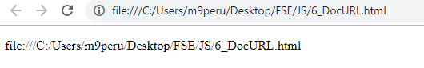

Code Snippet

<!DOCTYPE html>

<html>

<head>

<meta charset="utf-8">

<title>Write a JavaScript program to get the website URL (loading page)</title>

</head>

<body>

<p id="demo"></p>

<script>

var printURL = document.URL;

document.getElementById("demo").innerHTML = printURL;

</script>

</body>

</html>

Question 7

Write a JavaScript program to capitalize the first letter of each word of a

given string

Output

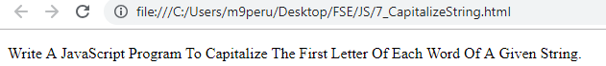

Code Snippet

<!DOCTYPE html>

<html>

<head>

<meta charset="utf-8">

<meta name="viewport" content="width=device-width">

<title>JavaScript program to capitalize the first letter of each word of a given string.</title>

</head>

<body>

<p id="demo"></p>

<script>

function capital_letter(str) {

str = str.split(" ");

for (var i = 0, x = str.length; i < x; i++) {

str[i] = str[i][0].toUpperCase() + str[i].substr(1);

}

return str.join(" ");

}

document.getElementById("demo").innerHTML = capital_letter("Write a JavaScript program to capitalize the first letter of each word of a given string.");

</script>

</body>

</html>

Question 8

Write a JavaScript program to check if a given string contai

ns equal

number of p's and s's present.

Sample output :

Input string :

paatpss

Output : true

Input string : paatps

Output : false

Output

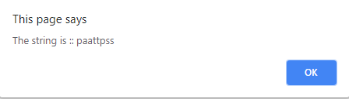

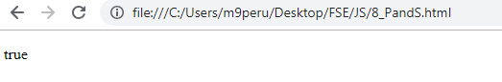

Code Snippet

<!DOCTYPE html>

<html>

<head>

<meta charset="utf-8">

<meta name="viewport" content="width=device-width">

<title>check if a given string contains equal number of p’s and t’s present.</title>

</head>

<body>

<p id="test"></p>

<p id="demo"></p>

<script>

function equal_pt(str) {

var val = str;

alert("The string is :: " + val)

var str_p = str.replace(/[^p]/g, "");

var str_t = str.replace(/[^t]/g, "");

var p_num = str_p.length;

var s_num = str_t.length;

return p_num === s_num;

}

document.getElementById("demo").innerHTML = equal_pt("paattpss");

</script>

</body>

</html>

Question 9

Write a JavaScript program to create a new string of 4 copies of the last

3 characters of a given original string. The length

of the given string

must be 3 and above.

Sample input 1: "Python 3.0"

Output 1:

3.03.03.03.0

Input 2:

"JS"

OUTPU

T2 :

false

Input

3 :

JavaScript

Output3:

Iptiptiptipt

Output

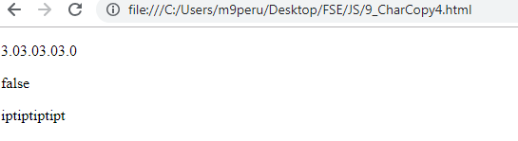

Code Snippet

<!DOCTYPE html>

<html>

<head>

<meta charset="utf-8">

<meta name="viewport" content="width=device-width">

<title>JavaScript program to create a new string of 4 copies of the last 3 characters of a given original string. The length of the given string must be 3 and above.</title>

</head>

<body>

<p id="test"></p>

<p id="demo"></p>

<p id="demo1"></p>

<script>

function newstring(str) {

if (str.length >= 3) {

result_str = str.substring(str.length - 3);

return result_str + result_str + result_str + result_str;

}

else

return false;

}

document.getElementById("test").innerHTML = (newstring("Python 3.0"));

document.getElementById("demo").innerHTML = newstring("JS");

document.getElementById("demo1").innerHTML = newstring("JavaScript");

</script>

</body>

</html>

Question 10.

Write a JavaScript program to swap the first and last elements of

a

given array of integers. The array length should be at least 1.

output

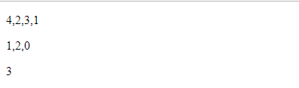

Code Snippet

<!DOCTYPE html>

<html>

<head>

<meta charset="utf-8">

<meta name="viewport" content="width=device-width">

<title>JavaScript program to swap the first and last elements of a given array of integers. The array length should be at least 1.</title>

</head>

<body>

<p id="test"></p>

<p id="demo"></p>

<p id="demo1"></p>

<script>

function swap(arra) {

[arra[0], arra[arra.length - 1]] = [arra[arra.length - 1], arra[0]];

return arra;

}

document.getElementById("test").innerHTML = (swap([1, 2, 3, 4]));

document.getElementById("demo").innerHTML = (swap([0, 2, 1]));

document.getElementById("demo1").innerHTML = (swap([3]));

</script>

</body>

</html>

Question 11.

Write a JavaScript function that reverse a number.

Using built in

functions.

Example x = 32243;

Expected Output :

34223

Output:

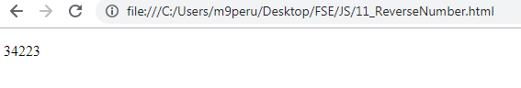

Code Snippet

<!DOCTYPE html>

<html>

<head>

<meta charset=utf-8 />

<title>Reverse a number</title>

</head>

<body>

<p id="test"> </p>

<script>

function reverse_a_number(n) {

n = n + "";

return n.split("").reverse().join("");

}

document.getElementById("test").innerHTML = reverse_a_number(32243);

</script>

</body>

</html>

Question 12.

Write a JavaScript function that returns a passed string with

letters in

alphabetical order. Using built in functions.

Example string :

'webmaster'

Expected Output :

'abeemrstw'

Assume punctuation and numbers symbols are not included in the

passed string.

Output



Code Snippet

<!DOCTYPE html>

<html>

<head>

<meta charset=utf-8 />

<title>Returns a passed string with letters in alphabetical order</title>

</head>

<body>

<p id="test"> </p>

<script>

function alphabet_order(str) {

return str.split('').sort().join('');

}

document.getElementById("test").innerHTML = alphabet_order("webmaster");

</script>

</body>

</html>

Question 13.

Write a JavaScript function that accepts a string as a param

eter

and find the longest word within the string.

Using builtin functions.

Example string

: 'Web Development Tutorial'

Expected Output :

'Development'

Write a JavaScript function to extract unique characters from a string.

Example string

: "thequickbrownfoxjumpsoverthelazydog"

Expected Output

: "thequickbrownfxjmpsvlazydg"

Write a JavaScript function to

get the numb

er of occurrences of each letter in

specified string.

Sample input :

The quick brown fox jumps over the lazy dog

Sample Output:

"T":1,"h":2,"e":3,"q":1,"u":2,"i":1,"c":1,"k":1,"b":1,"r":2,"o":4,"w

":1,"n":1,"f":1,"x":1,"j":1,"m":1,"p":1,"s":1,"v":1,"t":1,"

l":1,"a":

1,"z":1,"y":1,"d":1,"g":1

Output

Output



Code Snippet

<!DOCTYPE html>

<html>

<head>

<meta charset=utf-8 />

<title>Find the longest word within a string</title>

</head>

<body>

<p id="test"> </p>

<script>

function find_longest_word(str) {

var array1 = str.match(/\w[a-z]{0,}/gi);

var result = array1[0];

for (var x = 1 ; x < array1.length ; x++) {

if (result.length < array1[x].length) {

result = array1[x];

}

}

return result;

}

document.getElementById("test").innerHTML = find_longest_word('Web Development Tutorial');

</script>

</body>

</html>

Output:



Code Snippet

<!DOCTYPE html>

<html>

<head>

<meta charset=utf-8 />

<title>Extract unique character from a string</title>

</head>

<body>

<p id="test"> </p>

<script>

function unique_char(str1) {

var str = str1;

var uniql = "";

for (var x = 0; x < str.length; x++) {

if (uniql.indexOf(str.charAt(x)) == -1) {

uniql += str[x];

}

}

return uniql;

}

document.getElementById("test").innerHTML = unique_char("thequickbrownfoxjumpsoverthelazydog");

</script>

</body>

</html>

13.c

Output :



Code Snippet

<!DOCTYPE html>

<html>

<head>

<meta charset=utf-8 />

<title>=Number of occurrences of each letter in specified string</title>

</head>

<body>

<p id="test"> </p>

<script>

function Char_Counts(findcharacters) {

var CharList = [];

var CharCount = [];

var index = 0;

for (var i = 1; i <= findcharacters.length; i++) {

if (CharList.indexOf(findcharacters[i - 1]) > -1) {

// already there add the count

index = CharList.indexOf(findcharacters[i -1 ] );

CharList[index] = findcharacters[i-1];

CharCount[index] = CharCount[index] + 1;

}

else {

CharList.push(findcharacters[i - 1]);

CharCount.push(1);

++index;

}

}

var data="";

for (var j=0;j<CharList.length;j++)

{

data= data+ "\n Character " + CharList[j] + ' Count : ' + CharCount[j];

}

return data;

}

document.getElementById("test").innerHTML = Char_Counts("The quick brown fox jumps over the lazy dog");

</script>

</body>

</html>

14.

Write a JavaScript function that generates a string id (specified

length) of random characters.

Sample character list

:

"ABCDEFGHIJKLMNOPQRSTUVWXYZabcdefghijklmnopqrstuvwxyz0123456

789"

Length : 8

Output :

XppJs2BC

Output



Code Snippet

<!DOCTYPE html>

<html>

<head>

<meta charset=utf-8 />

<title>Generates a string id (specified length) of random characters</title>

</head>

<body>

<p id="test"> </p>

<script>

function makeid(l) {

var text = "";

var char_list = "ABCDEFGHIJKLMNOPQRSTUVWXYZabcdefghijklmnopqrstuvwxyz0123456789";

for (var i = 0; i < l; i++) {

text += char_list.charAt(Math.floor(Math.random() * char_list.length));

}

return text;

}

document.getElementById("test").innerHTML = makeid(8);

</script>

</body>

</html>

15.

Write

a JavaScript function to find longest substring in a given a

string without repeating characters.

Sample Input :

google.com

Sample Output:

gle.com

Sample input :

example.com

Sample output:

xample.co

Output:

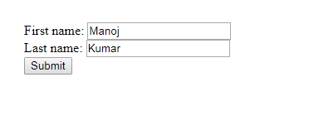

Code Snippet

<!DOCTYPE html>

<html>

<head>

<meta charset=utf-8 />

<title>Return first and last name from a form</title>

<style type="text/css">

body {

margin: 30px;

}

</style>

</head>

<body>

<form id="form1" onsubmit="getFormvalue()">

First name: <input type="text" name="fname" value="Manoj"><br>

Last name: <input type="text" name="lname" value="Kumar"><br>

<input type="submit" value="Submit">

</form>

<script>

function getFormvalue() {

var x = document.getElementById("form1");

for (var i = 0; i < x.length; i++) {

if (x.elements[i].value != 'Submit') {

document.getElementById("form1").innerHTML = x.elements[i].value;

}

}

}

</script>

</body>

</html>

16.

Write a JavaScript function to get the values of

First and Last name of the

following form.

Sample HTML file :

<!DOCTYPE html>

<html><head>

<meta charset=utf

-

8 />

<title>Return first and last name

from a form

-

w3resource</title>

</head><body>

<form id="form1" onsubmit="getFormvalue()">

First name: <input type="text" name="fname" value="David"><br>

Last name: <input type="text" name="lname"

value="Beckham"><br>

<input type="submit" value="Submit">

<

/form>

</body>

</html>

Output:

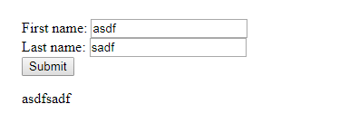

Code Snippet

<!DOCTYPE html>

<html>

<head>

<meta charset=utf-8 />

<title>Return first and last name from a form</title>

<style type="text/css">

body {

margin: 30px;

}

</style>

</head>

<body>

<form id="form1" onsubmit="event.preventDefault(); getFormvalue(); " action="" autocomplete="off">

First name: <input type="text" name="fname" id="fname"><br>

Last name: <input type="text" name="lname" id="lname"><br>

<input type="submit" value="Submit">

</form>

<p id="result"></p>

<script>

function getFormvalue() {

var data = "";

var x = document.getElementById("form1");

for (var i = 0; i < x.length; i++) {

if (x.elements[i].type != "submit") {

if (x.elements[i].type == "text") {

// Get the Element ID and compare

if (x.elements[i].value != "") {

data = data + x.elements[i].value;

}

}

document.getElementById("result").innerHTML = data;

}

}

}

</script>

</body>

</html>

17.

Here is a sample html file with a submit button. Write a JavaScript function

to get the value of the href, hreflang, rel,

target, and type attributes of the

specified link.

<!DOCTYPE html>

<html><head>

<meta charset=utf

-

8 />

</head>

<body>

<p><a id="w3r" type="text/html"

hreflang="en

-

us"

rel="nofollow" target="_self"

href="https://www.w3resource.com/">w3resource</a></p>

<button onclick="getAttributes()">Click here to get

attributes value</button>

</body></html>

Output:

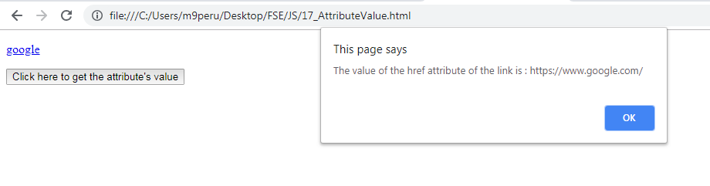

Code Snippet

<!DOCTYPE html>

<html>

<head>

<meta charset=utf-8 />

<title>Return first and last name from a form</title>

<style type="text/css">

body {

margin: 30px;

}

</style>

</head>

<body>

<form id="form1" onsubmit="getFormvalue()">

First name: <input type="text" name="fname" value="Manoj"><br>

Last name: <input type="text" name="lname" value="Kumar"><br>

<input type="submit" value="Submit">

</form>

<script>

function getFormvalue() {

var x = document.getElementById("form1");

for (var i = 0; i < x.length; i++) {

if (x.elements[i].value != 'Submit') {

document.getElementById("form1").innerHTML = x.elements[i].value;

}

}

}

</script>

</body>

</html>

18.

Write a JavaScript function to add rows to a table.

Sample HTML file :

<!DOCTYPE html>

<html><head>

<meta charset=utf

-

8 />

<title>Insert row in a table

-

w3resource</title>

</head><body>

<table id="sampleTable" border="1">

<tr><td>Row1 cell1</td>

<td>Row1 cell2</td></tr>

<tr><td>Row2 cell1</td>

<

td>Row2 cell2</td></tr>

</table><br>

<input type="button" onclick="insert_Row()" value="Insert

row">

</body></html>

Output:

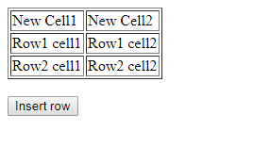

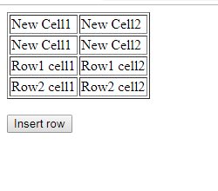

Code Snippet

<!DOCTYPE html>

<html>

<head>

<meta charset=utf-8 />

<title>Insert row in a table</title>

</head>

<body>

<table id="sampleTable" border="1">

<tr>

<td>Row1 cell1</td>

<td>Row1 cell2</td>

</tr>

<tr>

<td>Row2 cell1</td>

<td>Row2 cell2</td>

</tr>

</table><br>

<input type="button" onclick="insert_Row()" value="Insert row">

<script>

function insert_Row() {

var x = document.getElementById('sampleTable').insertRow(0);

var y = x.insertCell(0);

var z = x.insertCell(1);

y.innerHTML = "New Cell1";

z.innerHTML = "New Cell2";

}

</script>

</body>

</html>

19.

Write a JavaScript function

that accept row, column, (to identify a

particular cell) and a string to update the content of that cell.

Sample HTML file :

<!DOCTYPE html>

<html><he

ad>

<meta charset=utf

-

8 />

<title>Change the content of a cell</title>

</head><body>

<table id="myTable" border="1">

<tr><td>Row1 cell1</td>

<td>Row1 cell2</td></tr>

<tr><td>Row2 cell1</td>

<td>Row2 cell2</td></tr>

<tr><td>Row3 cell1</td>

<td>Row3 cell2<

/td></tr>

</table><form>

<input type="button" onclick="changeContent()" value="Change

content">

</form></body></html>

Output

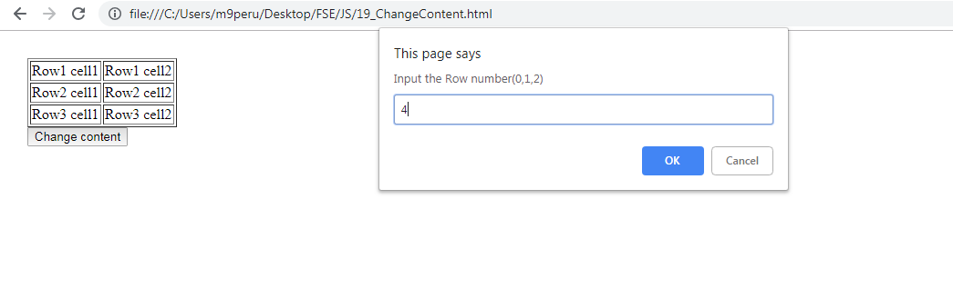

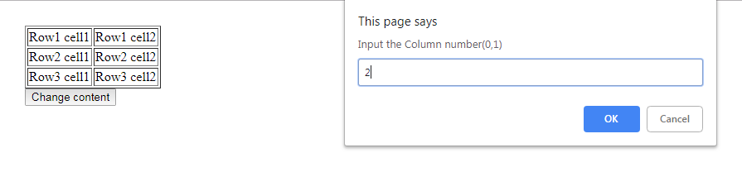

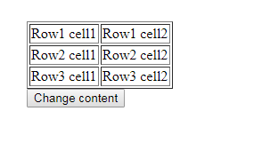

Code Snippet

<!DOCTYPE html>

<html>

<head>

<meta charset=utf-8 />

<title>Change the content of a cell</title>

<style type="text/css">

body {

margin: 30px;

}

</style>

</head>

<body>

<table id="myTable" border="1">

<tr>

<td>Row1 cell1</td>

<td>Row1 cell2</td>

</tr>

<tr>

<td>Row2 cell1</td>

<td>Row2 cell2</td>

</tr>

<tr>

<td>Row3 cell1</td>

<td>Row3 cell2</td>

</tr>

</table><form>

<input type="button" onclick="changeContent()" value="Change content">

</form>

<script>

function changeContent() {

rn = window.prompt("Input the Row number(0,1,2)", "0");

cn = window.prompt("Input the Column number(0,1)", "0");

content = window.prompt("Input the Cell content");

var x = document.getElementById('myTable').rows[parseInt(rn, 10)].cells;

x[parseInt(cn, 10)].innerHTML = content;

}

</script>

</body>

</html>

Question 20

Write a JavaScript program to remove items from a dropdown list.

Sample

HTML file :

<!DOCTYPE html>

<html><head>

<meta charset=utf

-

8 />

<title>Remove items from a dropdown list</title>

</head><body><form>

<select id="colorSelect">

<option>Red</option>

<option>Green</option>

<option>White</option>

<option>Black</option>

</sele

ct>

<input type="button" onclick="removecolor()" value="Select and

Remove">

</form></body></html>

Output

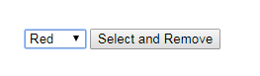



Code Snippet

<!DOCTYPE html>

<html>

<head>

<style type="text/css">

body {

margin: 30px;

}

</style>

<meta charset=utf-8 />

<title>Remove items from a dropdown list</title>

</head>

<body>

<form>

<select id="colorSelect">

<option>Red</option>

<option>Green</option>

<option>White</option>

<option>Black</option>

</select>

<input type="button" onclick="removecolor()" value="Select and Remove">

</form>

<script>

function removecolor() {

var x = document.getElementById("colorSelect");

x.remove(x.selectedIndex);

}

</script>

</body>

</html>